May 2020 Version 1.0

GENERAL

Palmer Timber Ltd have undertaken a Risk Assessment on the potential effects of the current COVID-19 pandemic relating to its activities & any persons who are directly or indirectly involved with its operations.
Government advice, information & guidelines have been reviewed in order to introduce appropriate procedures to prevent the transmission of the virus between persons working on site & other persons not based on site.

The company reminds staff, employees & all other persons involved with its operations that in order to minimise the risk of spread of the infection, we rely on everyone involved to take personal responsibility for their actions & behaviours. The company encourages an open & collaborative approach between persons working on site where any issues can be openly discussed & addressed.

ATTENDING WORK

- Employees who develop any of the specified symptoms relating to COVID-19 should not attend work & must inform their Line Manager immediately. They will be required to self-isolate in accordance with the current government guidelines which will be dependent upon their own personal circumstances.
- In situations where employees develop symptoms whilst on site, they will be isolated away from other persons & arrangements made for them to return back to their home.
- The company expects all employees to follow all self-isolating protocol & any ‘return to work’ at the end of these periods must be authorised by the appropriate Line Manager or Director.
- Where appropriate the NHS 111 service should be used & the company kept update accordingly.
- Any employee who does not attend work due to having COVID-19 symptoms or who lives with someone else who has COVID-19 symptoms must complete an ‘isolation-note’ & submit this to the company at the earliest practical opportunity (These are available online 111.nhs.uk/isolation-note)
- If you have an existing medical condition that would class you as a vulnerable person you must inform the company & your circumstances will be reviewed in line with the current government guidance.
- Where appropriate & where operational circumstances allow, alternative job roles on site will be considered for persons identified as a vulnerable person.
- In circumstances where employees have vulnerable persons in the same household, they should discuss these matters their Line Manager or the HR Manager so appropriate advice can be given.

Home working will be considered in circumstances where this is practical. This will be arranged at the company’s discretion following approval from the appropriate Line Manager or Director. Any employee who has COVID-19 symptoms & is authorised to work from home will not require an ‘isolation-note’.

SOCIAL DISTANCING & HYGIENE PROTOCOL

The company expects all persons to strictly follow the advised social distancing & hygiene protocol during both on site & off site work activities. It also reminds persons that these apply at home & within society in general.

Social distancing:

- All employees to remain a distance of 2m (6.5ft) away from other persons wherever practical.
- If the 2m distance cannot always be maintained in certain situations, then avoid direct face to face interaction & wear a mask or face covering.
- If you meet another person along a corridor, passageway or other access route then back-up or step aside so distancing protocol can be maintained.
- Follow procedures in specific areas where numbers may be limited at any one time to allow social distancing to be maintained. This may require you having to wait until it is safe to proceed.
- Any verbal communication & interaction with other persons should be undertaken at a safe distance & for the shortest period possible.
- Avoid any unnecessary movements around site & try to remain in your own working area wherever practical. If applicable & where safe to do so, use two-way radios, telephones & mobile phones for communication purposes which will reduce personnel movements around the site.

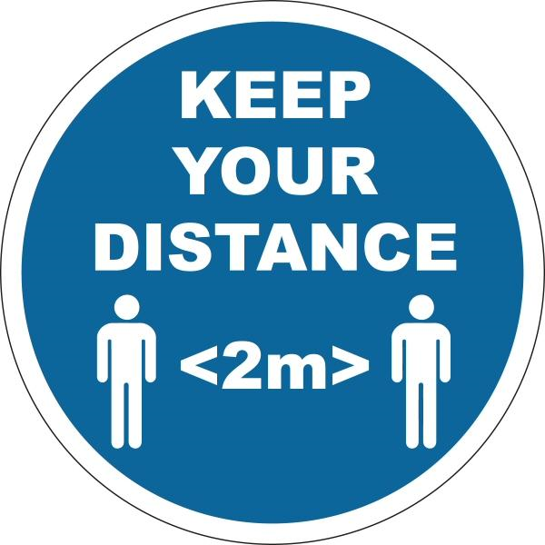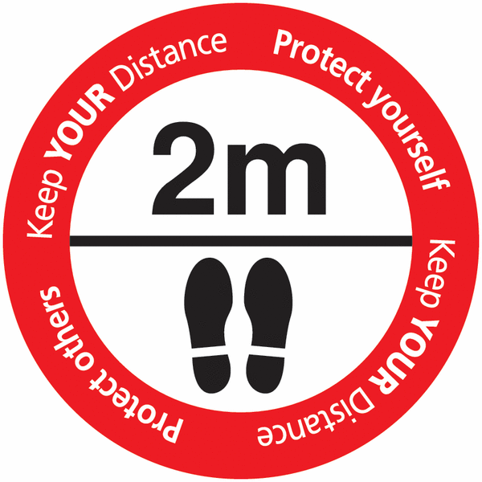

Hygiene:

Wash your hands thoroughly & regularly for at least 20 seconds at a time.
Use soap & water, or hand sanitiser to wash hands whilst adopting the advised NHS techniques.

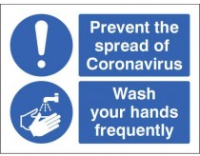

It is advised that you wash or sanitise your hands after the following situations:

- Upon arrival to work & prior to leaving site.
- Upon leaving a building area on site & prior to entering another building area (Scrub-in & Scrub-out)
- After using toilet areas on site.
- Before & after using communal canteen, kitchen & smoking shelter areas on site.
- Before each break-time & other natural breaks during the working day.
- Before & after operating plant, machinery, equipment or tools used by other persons.
- After completing job rotations e.g. working on a machine, unloading a delivery or picking an order.
- After coughing, sneezing or blowing your nose.

Other general hygiene protocol includes:

- When coughing & sneezing cover your mouth with a tissue or the sleeve of your arm. Discard the tissue into a bin afterwards & then wash your hands.
- Clean & disinfect regularly touched controls & surfaces using the antibacterial wipes provided.
- Avoid touching your face, eyes, nose & mouth with your hands.
- Avoid shaking hands & avoid sharing items or equipment.

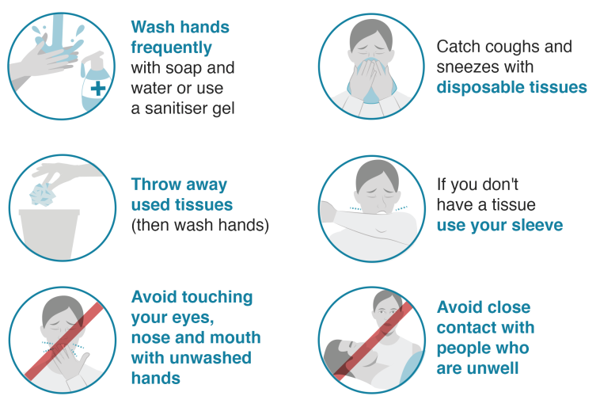

The company will provide additional hygiene products on site & issue these to remote workers upon request.

- Hand sanitiser.
- Antibacterial wipes.
- Disinfectant liquids & spray.
- Rolls of blue paper towel sheets.
- Latex gloves & masks.

Contract cleaners are deployed to clean designated office, toilet, canteen & kitchen areas on site.
Cleaning methods have been ramped up in light of the COVID-19 pandemic with use of specialist products.
VIRA+ service which uses a powerful disinfectant to clean surfaces (BS EN 14476 & BS EN 14675)

TRAVELLING TO WORK

It advised that public transport is not used as a regular method to get to your place of work. Wherever practical walk, cycle or use a car to get to work. Where the use of public transport cannot be avoided the government advises that social distancing protocol is followed & a face covering is worn if possible. Any persons who have COVID-19 symptoms or has someone in their household with these symptoms should not use public transport. It is advised that you do not share a car with other persons not in your household. Where this cannot be avoided then face coverings are advised & the vehicle kept well ventilated by opening the windows.

GENERAL BEHAVIOUR ON SITE

- Social distancing & hygiene protocol should be followed at all times.
- General movements around site should be kept to a minimum.
- Personal working areas & spaces should be respected at all times.
- The use of personal vaporizers is not permitted inside buildings or other enclosed areas.
- ‘Spitting’ is prohibited anywhere on site.
- Do not allow other persons to use or touch your mobile phone.

USE OF COMMON & SHARED AREAS ON SITE

The company is particularly aware that common & shared areas on site have a greater risk of persons potentially being closer to each other. There may be circumstances that persons will have to be show patience & wait to use certain areas within toilets, kitchens or canteens. This also applies to the reception & the yard office counter where only limited numbers of persons are allowed at the same time. If waiting or queuing to use these areas then social distancing protocol should be maintained. If you meet another person along a corridor or passageway then you should back-up or step aside so distancing protocol can be maintained.
The company would expect all persons to respect designated working areas around workstations.

GROUP MEETINGS ON SITE

Only essential group meetings will be undertaken & wherever practical remote working tools or methods will be used to avoid any non essential in-person contact. Where group meeting situations cannot be avoided the following general principles will be agreed & adopted to control the potential spread of the virus.

- No person with COVID-19 symptoms should attend group meeting situations.
- Group meetings should only be attended by the minimum persons required at one time.
- The meeting location should be spacious enough to allow all participants to remain 2m (6.5ft) apart.
- The group meeting should only last the minimum time required to sort out the required business.
- The meeting location should be well ventilated (Consider outside locations wherever practical)
- Hand sanitiser will be provided for use by all persons attending the group meeting.
- The sharing of items & equipment will be avoided e.g. pens, samples, drinking vessels etc.
- Group meeting participants should avoid shaking hands.

WORKING ACTIVITIES OFF SITE

The company recognises the potential risks relating to employees & staff who visit customer & suppliers premises as part of their work activities. Specific instructional guidance which outlines the general social distancing & hygiene protocol has been developed for these circumstances.

HGV & LGV drivers delivering to customer or supplier premises (See appendix 1)

Staff or employee visits to customer or supplier premises (See appendix 2)

Appendix 1

HGV DRIVERS VISITING CUSTOMER & SUPPLIERS PREMISES

INTRODUCTION

Due to the current national outbreak of Coronavirus (COVID-19) the company would like to highlight some important procedures & controls measures when you visit other sites whilst making deliveries &/or collections.
These instructions are based on government public health advice & information. They are necessary in order to protect yourselves & to minimise the risk of the virus spreading if coming into contact with infected or potentially infected people.

GENERAL PRECAUTIONS

- Keep the cab in your vehicle clean & hygienic. Remove waste & put into the nearest available bin.
- Keep a supply of alcohol-based hand rub in the vehicle cab & use this to wash your hands regularly throughout the day.
- Keep a supply of antibacterial wipes in the vehicle cab. Latex gloves are also available if required.
- Always remember to wash your hands thoroughly after using any toilet facilities.
- If any another person has been driving the vehicle, wipe the steering wheel, driver’s seat, operating controls & door handles with antibacterial wipes.

ARRIVAL AT CUSTOMR OR SUPPLIER PREMISES

- Where practical, engage in any interaction with persons on site from your vehicle cab.
- Keep the time spent outside the vehicle cab to a minimum whilst working on the curtain-sides, the load straps & the load itself.
- Do not engage in direct interaction with other persons at the premises & keep a distance of at least one metre where this cannot be avoided.
- Avoid entering any office or building areas at the premises.
- If having to use any facilities on site, avoid any direct interaction with persons at the premises.

OTHER INFORMATION

- If you develop symptoms of a dry cough, high temperature & a shortness of breath, you must contact your line manager immediately who will advise on what further action to take.
- If you require any further information on these instructions, please contact your line manager direct.

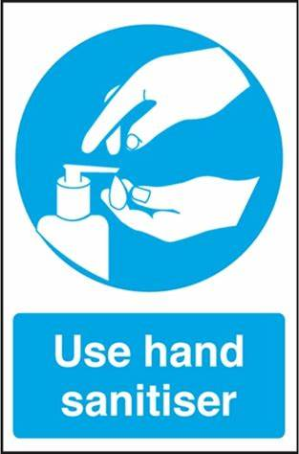

Appendix 2

COMPANY PERSONNEL VISITING CUSTOMER & SUPPLIERS PREMISES

INTRODUCTION

Due to the current national outbreak of Coronavirus (COVID-19) the company would like to highlight some important procedures & controls measures for personnel visiting customer & suppliers premises.
These instructions are based on government public health advice & information. They are necessary in order to protect yourselves & to minimise the risk of the virus spreading if coming into contact with infected or potentially infected people.

IMPORTANT

- All non-essential visits to customer & suppliers premises should be avoided.
- Alternative practical methods of communication should be adopted such as telephone calls, video calls & conference calls.
- Where the customer site visit cannot be avoided the following precautions must be followed.
- The number of persons visiting the customer premises should be kept to a minimum & any formal meetings should be kept as short as possible.
- DO NOT visit customer premises if you develop symptoms of a dry persistent cough, high temperature & a shortness of breath.

GENERAL PRECAUTIONS

- Keep your vehicle clean & hygienic. Remove waste & put into the nearest available bin.
- Keep a supply of alcohol-based hand rub in the vehicle & use this to wash your hands regularly throughout the day.
- Keep a supply of antibacterial wipes in the vehicle cab. Latex gloves are also available if required.
- Always remember to wash your hands thoroughly after using any toilet facilities.

ARRIVAL AT CUSTOMR OR SUPPLIER PREMISES

- Wash your hands thoroughly prior to entering the customer premises.
- Follow any further instructions displayed at the customer premises & read any applicable information.
- Avoid handshakes & physical contact whilst greeting people.
- Keep a distance of at least two meters during any direct interaction, especially within enclosed areas during meetings.
- If having to use any facilities on site, avoid any direct interaction with other persons at the premises.
- Wash your hands thoroughly after leaving the customer premises.

